**GANPAT UNIVERSITY**

**U.V.PATEL COLLEGE OF ENGINEERING & TECHNOLOGY**

**Department of Computer Science and Engineering**

**B.Tech 1ST  Semester   Subject –ESFP**

**First Name: Jagdish patil      Enrollment Number:T14012101004                      Stream : CBA**

**Date:-27/08/14**

Goal

**Practical -3**

**Objectives :**

**1. Write a program to print ASCII values of all backslash characters and white space on screen in following format :**

**The ASCII value of ‘\t’ is : 9**

**(Hint : you can verify your ASCII values with the help of a table for ASCII values from text book)**

**1.1**

**Code**

#include<stdio.h>

#include<conio.h>

void main()

{

char a,b,c,d,e,f,g,h,i,j,k,l,m;

a='\a';

b='\b';

c='\f';

d='\n';

e='\r';

f='\t';

g='\v';

h='\\';

i='\'';

j='\"';

k='\?';

l='\N';

m='\XN';

clrscr();

printf("\nThe Ascii value of \\a is :%d",a);

printf("\nThe Ascii value of \\b is :%d",b);

printf("\nThe Ascii value of \\f is :%d",c);

printf("\nThe Ascii value of \\n is :%d",d);

printf("\nThe Ascii value of \\r is :%d",e);

printf("\nThe Ascii value of \\t is :%d",f);

printf("\nThe Ascii value of \\v is :%d",g);

printf("\nThe Ascii value of \\\ is :%d",h);

printf("\nThe Ascii value of \\' is :%d",i);

printf("\nThe Ascii value of \\\" is :%d",j);

printf("\nThe Ascii value of \\\? is :%d",k);

printf("\nThe Ascii value of \\N is :%d",l);

printf("\nThe Ascii value of \\XN is :%d",m);

getch();

}

Output:-

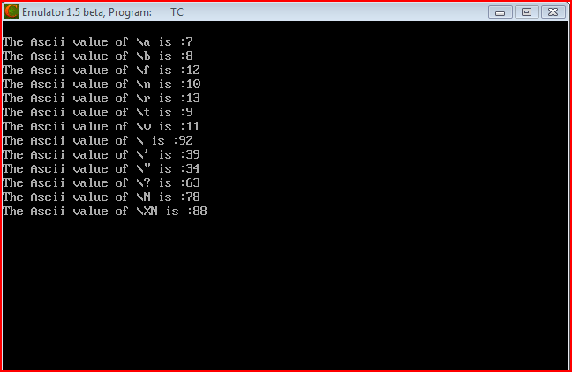



**2. Explain different data types available in C.**

**Ans:-**C has the following basic built-in datatypes.

int

float

double

char

Please note that there is not a boolean data type. C does not have the traditional view about logical comparison, but thats another story.

int - data type

int is used to define integer numbers.

{

int Count;

Count = 5;

}

float - data type

float is used to define floating point numbers.

{

float Miles;

Miles = 5.6;

}

double - data type

double is used to define BIG floating point numbers. It reserves twice the storage for the number. On PCs this is likely to be 8 bytes.

{

double Atoms;

Atoms = 2500000;

}

char - data type

char defines characters.

{

char Letter;

Letter = 'x';

}

Modifiers

The data types explained above have the following modifiers.

short

long

signed

unsigned

The modifiers define the amount of storage allocated to the variable. The amount of storage allocated is not cast in stone. ANSI has the following rules:

short int <= int <= long int

float <= double <= long double

What this means is that a 'short int' should assign less than or the same amount of storage as an 'int' and the 'int' should be less or the same bytes than a 'long int'. What this means in the real world is:

Type Bytes Range

---------------------------------------------------------------------

short int 2 -32,768 -> +32,767 (32kb)

unsigned short int 2 0 -> +65,535 (64Kb)

unsigned int 4 0 -> +4,294,967,295 ( 4Gb)

int 4 -2,147,483,648 -> +2,147,483,647 ( 2Gb)

long int 4 -2,147,483,648 -> +2,147,483,647 ( 2Gb)

signed char 1 -128 -> +127

unsigned char 1 0 -> +255

float 4

double 8

long double 12

These figures only apply to todays generation of PCs. Mainframes and midrange machines could use different figures, but would still comply with the rule above.

You can find out how much storage is allocated to a data type by using the sizeof operator discussed in Operator Types Session.

**3. Explain about C Tokens in brief.**

**Ans:-** C tokens are the basic buildings blocks in C language which are constructed together to write a C program.

Each and every smallest individual units in a C program are known as C tokens.

C tokens are of six types. They are,

Keywords (eg: int, while),

Identifiers (eg: main, total),

Constants (eg: 10, 20),

Strings (eg: “total”, “hello”),

Special symbols (eg: (), {}),

Operators (eg: +, /,-,*)

**4. Explain about backslash characters in C.**

**Ans:-**

Although it consists of two characters, it represents single character.

Each escape sequence has unique ASCII value.

Each and Every combination starts with back slash()

They are non-printable characters.

It can also be expressed in terms of octal digits or hexadecimal sequence.

Escape sequence in character constants and string literals are replaced by their equivalent and then adjacent string literals are concatenated

Escape Sequences are preprocessed by Preprocessor. C has a concept of 'data types' which are used to define a variable before its use. The definition of a variable will assign storage for the variable and define the type of data that will be held in the location.

The value of a variable can be changed any time